Neu-Ulm, 03rd December 2009

Success for SAUER BIBUS at the Agritechnica
ICVD drive technology conquers Europe

Participation at this year's Agritechnica, the world's largest trade fair for agricultural technology in Hanover, was a huge success for Neu-Ulm company SAUER BIBUS GmbH. SAUER BIBUS has specialised in the development and configuration of hydraulic drives and controls and, together with GKN Walterscheid, presented the ICVD drive, which increasingly is also being used on agricultural machinery, to the trade public at the trade fair. For the first time, an Italian manufacturer also presented the ICVD drive in its telescopic ladders at the trade fair.

The focus of the trade fair event for SAUER BIBUS at the Agritechnica in Hanover, was the hydrostatic ICVD drive. The success of the special drive is based on its large-angle technology. A hydraulic motor with a 45° large angle technology means the whole speed range becomes continuously variable. This means that machines that are used at higher speeds can do without a manual gearbox. For the operating personnel this means a clear gain in convenience and safety, as the driver can concentrate fully on driving his machine.

The ICVD is already being used as drive technology by manufacturers of large agricultural machinery. The Italian manufacturer DIECI has also presented vehicles with the ICVD drive from SAUER BIBUS for the first time at this year's trade fair in Hanover. "Thus, our drive concept has also made the leap into international use", commented Ralf Schrempp, Managing Director of SAUER BIBUS GmbH, on the success of his company.

At DIECI, the machines equipped with an ICVD drive are also given their own quality label. The Italian manufacturer points to the advances of the new traction drive system with the addition "VS" for "Vario System". Ralf Schrempp is convinced that the success will continue for SAUER BIBUS. The ICVD concept stands out for its profitability, which is based on an improved level of efficiency in the traction drive and greater user friendliness of the machine as a whole.

We are pleased that in DIECI we have now also found a large manufacturer in Italy as a partner for our drive technology, says Ralf Schrempp, underlining the success of SAUER BIBUS. DIECI has developed into a leading supplier of telescopic ladders on the international market over the last few years.

Photos

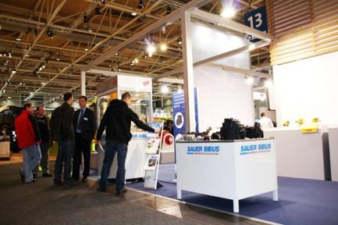
Picture 1 - SAUER BIBUS at the Agritechnica 2009. Many visitors to the stand found out about the ICVD drive technology for agricultural machinery.

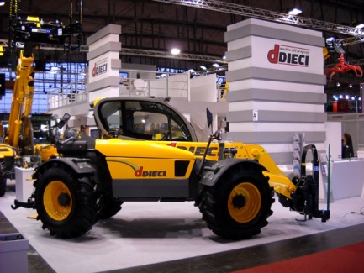
Picture 2 - The Italian telescopic ladder manufacturer DIECI also relies on the ICVD technology of SAUER BIBUS and presented vehicles with this drive technology under its "VS" label, which stands for "Vario System".

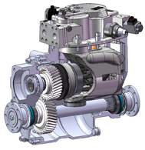

Picture 3 - ICVD drive with large-angle technology. The large angle technology up to 45° allows continually adjustable traction drive control.

You can download pictures for this press release at
www.press-n-relations.de.

Contact:
SAUER BIBUS GmbH
Lise-Meitner-Ring 13
D-89231 Neu-Ulm
Tel.: +49 (0)731 189 60
Fax +49 (0)731 189 6119
info@sauerbibus.de
www.sauerbibus.de

Press Office:
Yource GmbH - Lothar Riesenegger
Magirusstraße 33
D-89077 Ulm
Tel.: +49 (0)731 962 8782
Mobile +49 (0)171 873 0916
lothar.riesenegger@yource.de
www.yource.de

More on SAUER BIBUS
SAUER BIBUS GmbH with headquarters in Bavarian Neu-Ulm, develops innovative solutions for complete hydraulic systems for static industrial plant and for mobile use. The company has developed from a retail company for hydraulic components into a full-service supplier. Thanks to in-house product development, SAUER BIBUS can offer tailor-made customer solutions, which offer a high level of efficiency and profitability. In addition to development and sales, the hydraulic specialist offers professional servicing and repairs at its Neu-Ulm site.

