Press Release

Ulm (D) / Huntsville (USA), January 20th, 2010

Wolverine Tube and the Wieland Group
form global heat transfer technology company

With effect from 1st January 2010 Wolverine Tube, Inc. (“Wolverine”) and the Wieland Group (“Wieland”) have formed the company Wolverine/Wieland Heat Transfer Technologies, LLC (“WWHTT”), a joint venture of Wolverine and Wieland which will develop innovative and energy efficient heat transfer technology.
The new company, with facilities in Huntsville, Alabama (USA) and Ulm (Germany) is expected to accelerate the pace of heat transfer innovation, reduce the cost of technology development, and increase the competitiveness of customers’ products.

“The heat transfer markets we serve demand constant innovation. WWHTT will develop technologies that allow engineers to create air conditioning and refrigeration systems with higher efficiency, lower end-user operating cost, and reduced refrigerant use,” said Harold Karp, Vice President and Chief Operating Officer of Wolverine.

“The rapidly changing technical requirements of our markets will only be met by an ability to revolutionize heat transfer technology. WWHTT will leverage the heat transfer technology of two world-class companies to create best-in-class solutions for our customers and markets”, said Bernd Grasshof, Vice President of Wieland’s Tube Division.

Pictures:

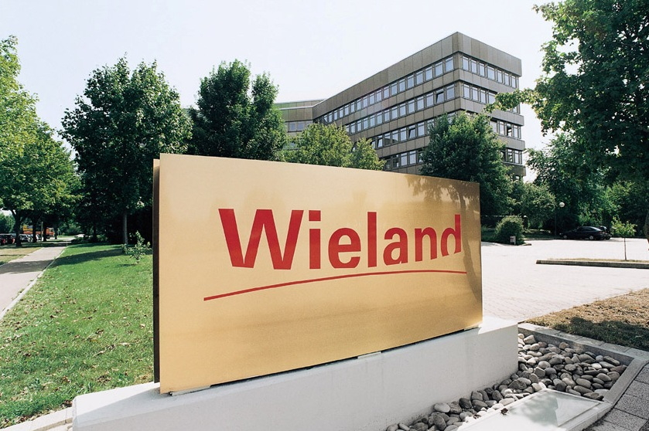
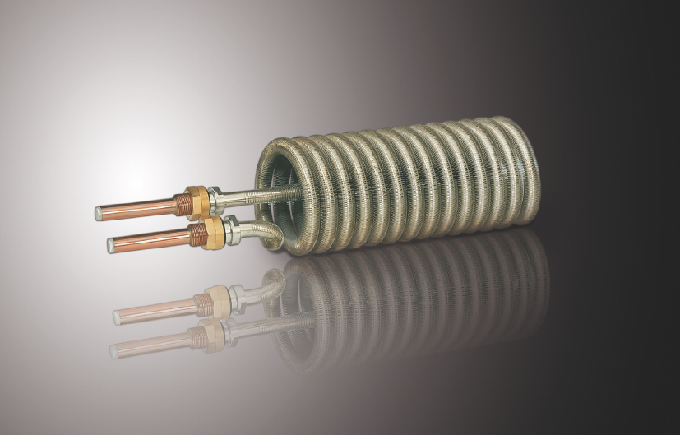

Wieland headquarters in Ulm (Germany)
Wieland heat exchanger based on a finned tube

Pictures can be downloaded under www.press-n-relations.de in the annex of the press release.

Further information:
Wolverine Tube, Inc.
David W. Jordan
Vice President Business Operations and Strategy
Tel.: +1 (256) 580-3695
david.jordan@wlv.com
www.wlv.com

Wieland-Werke AG
Bernd Graßhof
Vice President Tube Division
Graf-Arco-Straße 36 D - 89079 Ulm
Tel: +49 731-944-2722
bernd.grasshof@wieland.de
www.wieland.de

Wieland-Werke AG  Karin Maier  Public Relations  Graf-Arco-Straße 36 D - 89079 Ulm  Tel: +49 731-944-2663  Fax: +49 731-944-42663  karin.maier@wieland.de  www.wieland.de | Public Relations:  Press’n’Relations GmbH  Bruno Lukas  Magirusstraße 33 D - 89077 Ulm  Tel: +49 731-9628717  Fax: +49 731-9628797  blu@press-n-relations.de  www.press-n-relations.de

Wieland Group

The Wieland Group is one of the world’s leading producers of semi-finished and special products in copper and copper alloys, including strip, sheet, tube, rod, wire, sections, slide bearings, finned tubes, and heat exchangers. Wieland supplies customers in numerous markets, producing over 100 different copper alloys, which are used in the electrical and electronic industry, automotive industry, in construction and mechanical engineering as well as heating, air-conditioning and refrigeration industries. Together with its customers Wieland develops solutions for individual and industrial applications. The Wieland Group operates over 30 production sites, slitting centers, and trading companies in Europe, North America, Asia, and Africa. The global workforce of the Wieland Group is approx. 6,500 strong of which 4,000 are employed in Germany.

Wolverine Tube, Inc.

Wolverine Tube, Inc. is a world-class producer of copper and copper alloy tube, fabricated products, and metal joining products. It is a publicly traded Delaware corporation organized in 1987 (WLVT), and is a successor to a business founded in Detroit, Michigan in 1916. Wolverine’s principal products are commercial, high value-added products sold directly to original equipment manufacturers (OEMs). Wolverine has approximately 1,500 employees worldwide.

