Zuchwil, 22. October 2019

“We love it your way”
Market relaunch makes Schaerer’s self-image something you can experience on all levels

Customer-oriented, extremely flexible and with extensive coffee knowledge, Schaerer supports customers of any size all over the world in offering their guests the highest level of coffee enjoyment. What unites them all: Instead of an “off the rack” solution, at Schaerer, you get a customised concept which put your needs and your business model at centre stage. Schaerer is highlighting this self-image with its new market relaunch and the core message “We love it your way”. The new brand image was developed together with the lead agency Studio Volpi from Italian Carnage/Varese.

As a traditional company with many years of history, the Schaerer brand stands for Swiss values combined with in-depth knowledge of coffee. The company expresses these brand attributes with the claim of the company logo “swiss coffee competence” and experiences them equally in its product development and in the Coffee Competence Centre, Schaerer’s own coffee expertise and training centre in Zuchwil. Moreover, the brand is characterised by its own flexible solutions, be they in reference to customer requests, customer-specific products and large orders or the product range which offers the customer optimal customised solutions. “With the core message ‘We love it your way’, we are even more strongly underlining Schaerer’s self-image and our promise to our customers. For us, the customers and their individuality is at centre stage. A close, friendly partnership on equal footing is just as important to us as the provision of the coffee machine technology and services which they actually need for their respective business model”, explains Sarah Ognibeni, Head of Marketing & Coffee Competence Centre. With this standard as a starting point, coffee concepts are created which make the coffee business of Schaerer customers even more successful worldwide. Today as well as tomorrow. Finally, the digital applications such as the Schaerer Coffee Link guarantee that the customised solution packages can be quickly and easily adapted to future customer and market requirements - be they in machine configuration, beverage offerings or new, digital customer touch points.

Experience “We love it your way”
“Our trade fair booth design, the newly-developed information and product brochures as well as advertising materials make it much more tangible what Schaerer as a brand stands for, which values the customers appreciate and which motivate and encourage the employees in their daily work”, explains Sarah Ognibeni. The “We love it your way” self-image and the associated customer promise also shows the way for the further development of the Schaerer product and service portfolio. “We are moving even closer to the customer. We are becoming quicker and more agile - both when it comes to technologies and services - and are therefore redefining the term “customised” in the industry”, explains Ognibeni.

www.schaerer.com

Image material
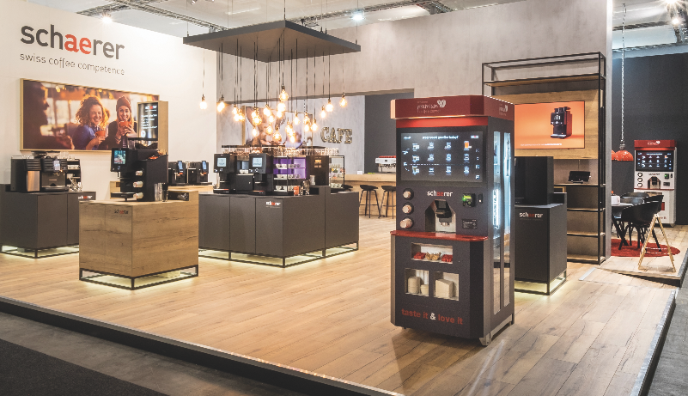  Include as Copyright:  Kjeld Meyer – didid – brand environments | 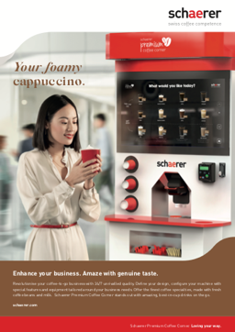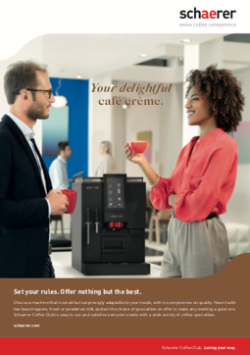
Instead of an “off the rack” solution, at Schaerer, you get a customised concept which put your needs and your business model at centre stage. Schaerer is highlighting this self-image with its new market relaunch and the core message “We love it your way”.

Image availability
You can find downloadable image material in our media portal press-n-relations.amid-pr.com (search term “Brandrelaunch-2019”). Of course, I would also be happy to send you the file by e-mail. Contact: nfo@press-n-relations.de

Further information:
Schaerer AG, Sarah Ognibeni
Head of Marketing & Coffee Competence Centre, Allmendweg 8, 4528 Zuchwil
Tel.: +41 32 681 64 02
sognibeni@schaerer.com
www.schaerer.com

Schaerer Press Office
c/o Press'n'Relations GmbH,
Nataša Forstner
Magirusstrasse 33, D-89077 Ulm, Germany
Tel.: +49 731 96 287-17
Fax: +49 731 96 287-97
nfo@press-n-relations.de
www.press-n-relations.de

Schaerer AG
Founded in 1892 and headquartered in Zuchwil, near Solothurn, Switzerland, Schaerer AG is one of the world's leading manufacturers of fully automatic professional coffee machines and offers solutions to suit all needs and performance requirements. Schaerer AG is represented internationally with subsidiaries in Germany, Belgium and the US and over 70 partner companies on all five continents. Schaerer has been part of the WMF Group since 2006 and of the French consortium Groupe SEB since the end of 2016.

Customers all over the world value Schaerer products for their ease of use, the large selection of coffee types available at the touch of a button and the excellent quality of their coffee. Numerous innovations, including the revolutionary, patented Best Foam milk system, highlight the company's pioneering approach. The strapline “swiss coffee competence” is founded on the Swiss engineering skills on which it draws and its far-reaching coffee expertise. Schaerer combines coffee machine technology and many years of coffee expertise with the skill of a barista: Inside the coffee machines, all the details are perfectly coordinated to prepare beverages that are equal in taste and appearance to the coffee creations handcrafted by baristas.

