World of Coffee 2019, 6.- 8. Juni, Messe Berlin ExpoCenter City, Stand I8

Zuchwil – 09.05.2019

Schaerer shows espresso competence at the World of Coffee in Berlin

At the World of Coffee 2019 in Berlin, swiss coffee machine manufacturer Schaerer focuses on the Schaerer ‘Barista’ machine. The high espresso quality, the elegant design – inspired by the classic portafilter machine – and the extremely easy handling make the Schaerer ‘Barista’ ideal for a wide range of applications, from coffee shop chains to owner-run coffee bars or Italian restaurants. "The espresso machine chimes with the zeitgeist in the industry at the moment. It helps restaurateurs to celebrate barista-style coffee culture – in terms of appearance, technology and skills. At the same time, they can count on exceptionally easy operation and maximum process reliability," says Sarah Ognibeni, Head of Marketing and Coffee Competence Centre at Schaerer AG.

The Schaerer Barista combines the fundamental principles of a portafilter machine and the skills of a barista with the easy operation and process reliability of a fully automatic coffee machine. The result is the perfect Italian espresso with consistent quality from cup to cup. All the operator has to do is insert the portafilter and touch a beverage button according to the coffee you want. At the same time, the typical sounds that accompany traditional steps such as knocking out the portafilter or frothing the milk create a sense of Italian flair. If the guest would like a milk-based coffee specialty, perfect milk foam is available manually done or at the touch of a button on the Schaerer Barista display: the Supersteam wand will conjure up milk foam automatically in up to three predefined consistencies and temperatures. In addition, the manual steam nozzle can also be used for traditional frothing.

Playground for baristi
The hybrid technology of the Schaerer espresso machine provides an interesting alternative for professional baristi. The barista can set all of the relevant parameters individually for the desired taste profile in order to get the best out of a particular roast coffee blend. This profile can then be accessed by anyone to ensure that the coffee specialities are prepared to the same high quality standards by every employee. The two integrated grinders allow you to use different types of bean, with the option of adding extra recipes for beans in external grinders if desired. Thanks to the two steam wands, you can choose between manual milk frothing or automatic preparation via Supersteam.

www.schaerer.com

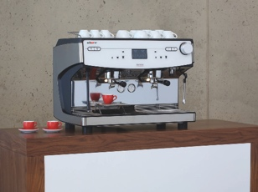 | 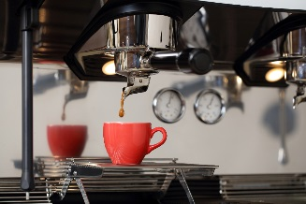 | 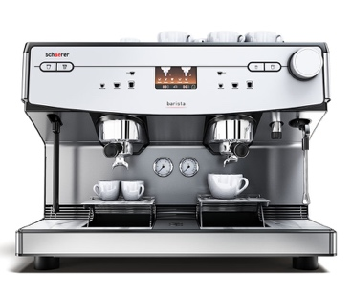
The Schaerer Barista helps restaurateurs to celebrate barista-style coffee culture and prepare the perfect Italian espresso and with more time for their customer. |  | The Schaerer Barista combines the fundamental principles of a portafilter machine and the skills of a barista with the easy operation and process reliability of a fully automatic coffee machine.

Image availability
You can find downloadable image material in our media portal press-n-relations.amid-pr.com (search term "Schaerer-Barista"). Of course, I would also be happy to send you the file by e-mail. Contact: nfo@press-n-relations.de

Further information:
Schaerer AG, Sarah Ognibeni
Head of Marketing & Coffee Competence Centre Allmendweg 8, 4528 Zuchwil
Tel.: +41 32 681 64 02
Fax: +41 32 681 64 04
sarah.ognibeni@schaerer.com
www.schaerer.com

Schaerer Pressebüro
c/o Press’n’Relations GmbH, Nataša Forstner
Magirusstraße 33, D-89077 Ulm
Tel.: +49 731 96 287-17
Fax: +49 731 96 287-97
nfo@press-n-relations.de
www.press-n-relations.de

Schaerer AG
Founded in 1892 and headquartered in Zuchwil, near Solothurn, Switzerland, Schaerer AG is one of the world's leading manufacturers of fully automatic professional coffee machines and offers solutions to suit all needs and performance requirements. Schaerer AG is represented internationally with subsidiaries in Germany, Belgium and the US and over 70 partner companies on all five continents. Schaerer has been part of the WMF Group since 2006 and of the French consortium Groupe SEB since the end of 2016.

Customers all over the world value Schaerer products for their ease of use, the large selection of coffee types available at the touch of a button and the excellent and consistent quality of their coffee beverage. Numerous innovations, including the revolutionary, patented Best Foam milk system, highlight the company's pioneering approach. The strapline “swiss coffee competence” is founded on the Swiss engineering skills on which the company draws and its far-reaching coffee expertise Schaerer combines coffee machine technology and many years of coffee expertise with the craftsmanship of a barista: inside the coffee machines everything meshes perfectly to make drinks that are on a par with the hand-made creations of a barista, in terms of both taste and appearance.

