Birkenfeld, 9 December 2019

An all-round talent when it comes to coffee and tea
New double-walled pot collection “COMPO” from WMF Professional

Whether breakfast, afternoon coffee or room service – with the double-walled pots in the “COMPO” collection, WMF Professional presents the perfect accompaniment for delicious coffee and tea pleasure. The new series impresses not only with its variety, which leaves nothing to be desired. With a skilful change of shape from the quadratic base shape to the rounded upper pot area, the design also flatters any table ambience. COMPO is thus in harmony with almost any style of porcelain, cutlery and decorative item.

Attractive and convincing in form and function – the new double-walled stainless steel pots for coffee and tea meet every demand made of first-class service. Depending on the requirement, the restaurateur can choose between coffee pot, coffee press, tea pot plus tea strainer as well as milk pot and water pitcher. Different size options for volumes ranging from 0.3 to 1.2 litres guarantee perfect harmony with all other elements on the laid table. The new pot also demonstrates flexibility - and thus investment protection - in combination with other table-top elements from WMF Professional, for example, the “URBAN” collection.

The dishwasher-safe, double-walled 18/10 stainless steel ensures that pleasure and handling go hand-in-hand: tea and coffee remain hot for a very long time, whereby drip-free pouring and a very well balanced pouring action ensure simple handling. The same level of comfort also applies to the pot lid in the COMPO collection. This can be opened 180 degrees so that the pot can also be thoroughly cleaned inside.

www.wmf-professional.com

Image request
You can find and download images from our media portal http://press-n-relations.amid-pr.com by searching for the term „WMF-Compo“.

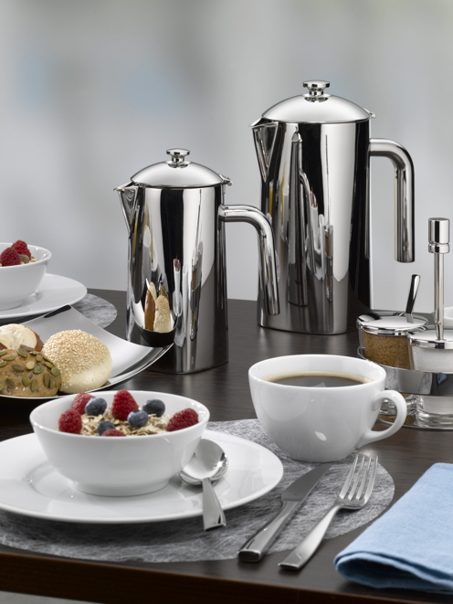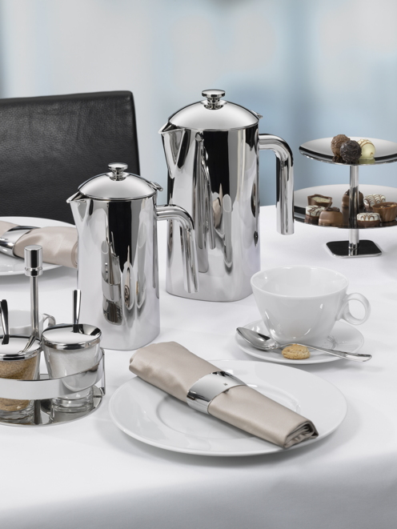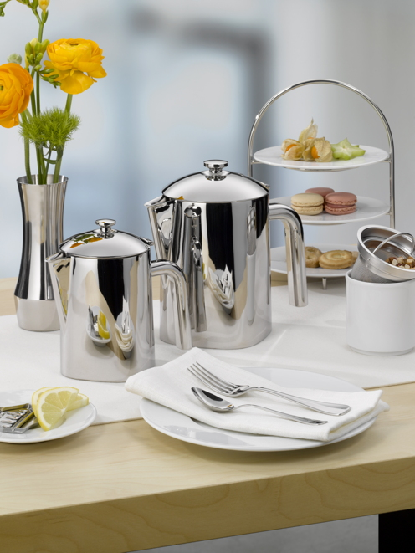

Further information:  proHeq GmbH  WMF Professional  Carl-Benz-Str. 10  75217 Birkenfeld  Tel. +49 7231 4885 0  Fax +49 7231 4885 83  wmf@press-n-relations.de  www.wmf-professional.de | Press and public relations:  WMF Press Office  c/o Press’n’Relations GmbH  Monika Nyendick  Magirusstraße 33 – D-89077 Ulm  Tel. +49 731 96287-30  Fax +49 731 96287-97  wmf@press-n-relations.de  www.press-n-relations.de

About the WMF Group
For more than 160 years, WMF has been dedicated to achieving the perfect balance of design, functionality and quality. Our employees are passionate about bringing people together, whether at home, on the move or at fine-dining establishments, in order to give them shared moments that are both precious and delicious. All this with products which have outstanding design, perfect functionality and excellent quality to make every culinary experience a real joy.

WMF Professional as a brand of proHeq GmbH is one of the leading providers of professional equipment for hotels and the catering industry. The key strength of this long-established business unit professional hotel equipment is its innovative, painstakingly crafted and stylish all-in-one solutions covering every aspect of food and drink, from preparation to serving. The extensive product range includes cutlery and glassware, serving and buffet equipment and table decorations in every colour.

At the end of 2016, proHeq GmbH became part of the French Groupe SEB consortium. In this context, all B2B brands of the Group were recently brought together under the umbrella “SEB PROFESSIONAL.” In addition to Professional Hotel Equipment with the brands WMF Professional and HEPP, the umbrella brand also includes WMF, Schaerer and Wilbur Curtis.

