Geislingen an der Steige, 23th November 2020

The ultimate coffee experience – and a secure investment
WMF celebrates the launch of the new automatic coffee machine WMF 1300 S

Delivering outstanding performance in a compact, versatile package, the WMF 1300 S is premium manufacturer WMF’s new addition to its product portfolio: a speciality machine with a range of new features for even greater dependability and serviceability. With a recommended daily capacity of up to 120 cups on average, and up to three optionally lockable hoppers, this new fully automatic machine provides a reliable choice for all kinds of operations that serve coffee. The milk system ensures that the quality of the beverages remains consistently high, whether they use hot milk or hot milk foam. The machine is enhanced by features including an intelligent design concept that provides efficient access for servicing.

Designed to Perform
With its slim dimensions (W x H x D of 32.5 x 66.9 x 57.4 centimetres), appealing choice of equipment and optional constant water supply, the WMF 1300 S delivers long operation times and a fast return on investment in a truly impressive package. The fully automatic machine can be equipped with two bean hoppers, a powder hopper with a 1200-gramme capacity and a manual insert for ground coffee, depending on which machine variant is selected. In WMF 1300 S models that operate without powder, each of the two bean hoppers holds 650 grammes, while the models with a powder hopper offer capacities of 650 grammes (right-hand hopper) and 550 grammes (centre hopper). Restaurateurs and hoteliers whose priority is flexibility will also benefit from a four-litre water tank and the basic model’s reduced weight of 35 kilogrammes. What’s more, lockable hoppers ensure the machine can be used without issues in self-service operations.

Customers have the option of tailoring products to the type of operation (self-service or staff-operated) by using configurable templates designed for the fully automatic machine. The seven-inch touch display allows users to swipe vertically through all the functions available, which include settings for recipes, images and colour concepts, plus cleaning and care programs. For even more convenience, the function bar at the bottom edge of the display features special preset functions and can be customised with numerous options to suit both guests and staff.

A new approach to machine maintenance
Where its design is concerned, the WMF 1300 S also delivers on its manufacturer’s commitment to process efficiency. The access points for servicing components as necessary have been optimised, while the machine concept makes it possible to remove the side walls, rear cover and lid independently from one another so that specific parts of the machine can be reached. This makes it much easier and quicker to work on the machine, even in tight spaces behind bar counters, in kitchenettes within offices or elsewhere.

Well-designed convenience for everyday operation
The key features of the new WMF 1300 S demonstrate the sheer attention to detail that has been devoted to this machine: they include a height-adjustable spout and a Cup Stop for ensuring that cups, mugs and glasses are positioned in exactly the right place. Adjusting the coffee spout is easy, with a clearance height of 60 to 169 mm available. And not only that, but the optional decentralised hot water spout is at a height of 107 mm.

The integrated milk system cater to any beverage requirements that a restaurateur may have: the Basic Milk system delivers hot milk and hot milk foam of the very highest quality. Additional Basic Steam wand makes it possible to produce hot milk and milk foam manually. And if the user doesn’t have a heated cup rack available, the integrated SteamJet feature is able to bring cups and glasses up to the correct temperature.

The machine features even more convenient functions to keep everything running smoothly, including a fill level sensor that prevents the drip tray from overflowing. Beverage dispensing is also blocked if the bowl is missing or incorrectly positioned in the machine, ensuring process reliability and stability. A similar concept has been applied to the mixer wheel in the powder hopper: if it is not correctly attached, the sensors will issue a message that is then shown on the display.

Image request
You can find images on our media portal http://press-n-relations.amid-pr.com
(Search term: WMF1300S)

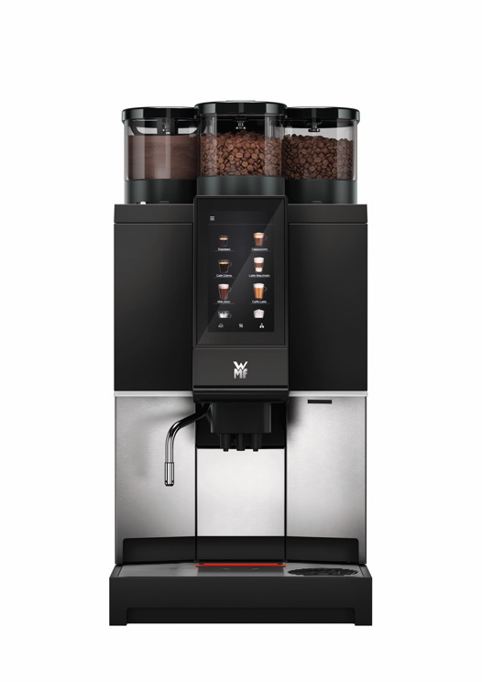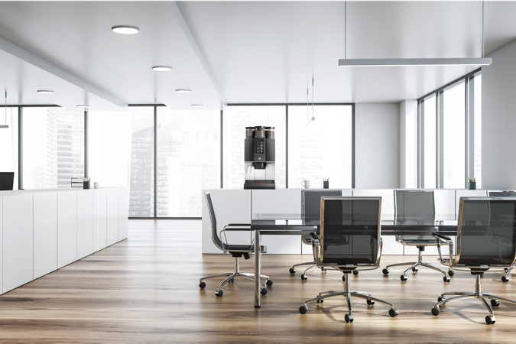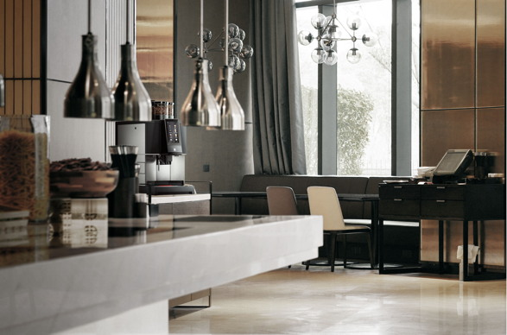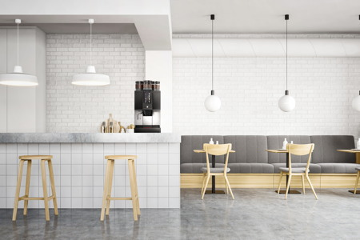
Further information:  WMF Group GmbH  Eva Gold  Senior Manager Global Brand & Communications  GBU Professional Coffee Machines  Eberhardstraße 35 – 73312 Geislingen, Germany  Tel.: +49 73 31 25 8589  EGold@wmf.com - www.wmf.com | Press and public relations:  WMF Pressebüro  c/o Press’n’Relations GmbH  Monika Nyendick  Magirusstraße 33 – 89077 Ulm, Germany  Tel.: +49 731 96287-30  wmf@press-n-relations.de  www.press-n-relations.de

About the WMF Group
For over 160 years, WMF has been dedicated to achieving the perfect balance of design, functionality and quality. The company, based in southern Germany, is a global market leader in the Professional Coffee Machines (PCM) sector. With the aim of being the first choice worldwide for professional coffee solutions, the “made in Germany” quality seal combines premium products and innovative strength with peak performance and reliability.

At the core of the WMF PCM solutions portfolio is a clear message: Designed to Perform. The business unit from Geislingen an der Steige has just the right concept for every business model in the coffee sector – from high-performance fully automatic machines for coffee specialities and filter machines right through to fully automatic portafilters and innovative digitalisation concepts. Moreover, national and international customers alike benefit from high-quality consulting and service, based on the largest in-house service organisation for professional coffee machines in Europe. Regular training courses in the WMF training centres ensure that this expertise is continuously passed on to the entire global WMF service network.

At the end of 2016, WMF Group became part of the French Groupe SEB consortium. In this context, all B2B brands of the Group were recently brought together under the umbrella “SEB PROFESSIONAL”. In addition to WMF PCM, the umbrella brand also includes Schaerer and Wilbur Curtis coffee machines as well as the business division Professional Hotel Equipment with the brands WMF Professional and HEPP.

