Geislingen/Steige, 21st October 2019

“Designed to Perform”
Brand relaunch of WMF Professional Coffee Machines underscores global leadership in quality and innovation

Since 1927, professional coffee machines from WMF have lived up to a clear promise: seamless premium experience created through the combination of coffee excellence, reliable solutions and unparalleled service, with the aim of optimising customers’ coffee business on a long-term basis. Now the coffee machine manufacturer is emphasising its commitment to quality leadership “made in Germany” with its latest brand relaunch. The new “Designed to Perform” signature promises an unrivalled level of performance and investment security along the entire customer journey.

As a way of demonstrating the company’s complete customer focus, “Designed to Perform” underscores the combined technological and coffee expertise which ensures that each and every customer is offered the right premium products, functions and services to provide them with consistently high coffee quality and process reliability. But that’s not all. The new performance promise also concentrates on consistently optimising and ensuring the future viability of the coffee business. “As a full service provider, our solutions are more than simply the driving force for process improvements and increased sales in the daily business of our customers. They also represent a highly agile culture of innovation which we pass on to our customers through new stimuli,” explains Viola Linke, Vice President Global Marketing, GBU Professional Coffee Machines of the WMF Group. This continuous dialogue and know-how transfer takes place via functional and digital innovations as well as through consultation services in the areas of coffee excellence and digital business expertise. “This enables us to provide our customers with a central platform for new business models which fully exploit the commercial potential offered by the digital revolution,” clarifies Linke further. The new brand identity of WMF Professional Coffee Machines is consolidated with the aim of always being the customer’s first choice worldwide for professional coffee solutions.

The visual design was realised in accordance with the principle “Product is the hero”. “Unusual light reflections and the high-quality presentation of the elegant materials on a dark background underscore the premium character and create the ideal setting for each individual product. With great attention to detail, we developed a specific background for each machine – in exactly the same way that we create our coffee machines. This produced a special 3D effect, providing the perfect stage for each product,” explained Viola Linke.

The brand relaunch was developed by creative company Studio Volpi, which is based in Carnage/Varese, Italy. With its team of 50 creative professionals who collaborate across disciplinary borders, Studio Volpi was the optimum partner for a successful realignment of the brand identity.

Image request
You can find images on our media portal http://press-n-relations.amid-pr.com (search term “WMF_Designed-to-Perform”)

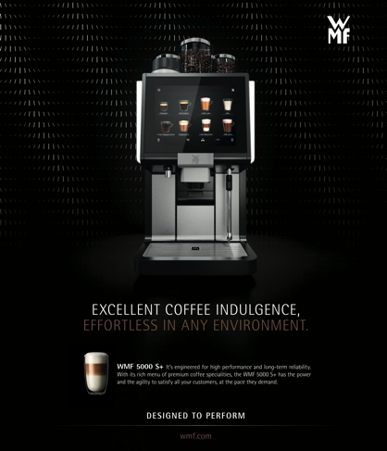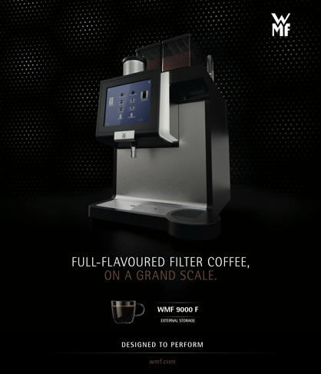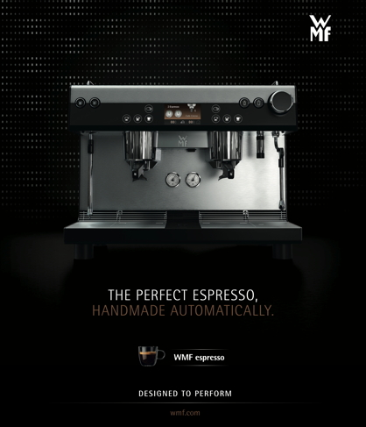

Further information:  WMF Group GmbH  Eva Gold  Senior Manager Global Brand &  Communications  GBU Professional Coffee Machines  Eberhardstraße 35 – 73312 Geislingen,  Germany  Tel.: +49 73 31 25 8589  EGold@wmf.com – www.wmf.com | Press and public relations:  WMF Pressebüro  c/o Press’n’Relations GmbH  Monika Nyendick  Magirusstraße 33 – 89077 Ulm, Germany  Tel.: +49 731 96287-30  wmf@press-n-relations.de  www.press-n-relations.de

About the WMF Group
For more than 160 years, WMF has been dedicated to achieving the perfect balance of design, functionality and quality. The company, based in southern Germany, is a global market leader in the Professional Coffee Machines (PCM) sector. With the aim of being first choice worldwide for professional coffee solutions, the “made in Germany” quality seal combines premium products and innovative strength with peak performance and reliability.

At the core of the WMF PCM solutions portfolio is a clear message: Designed to Perform. The business unit from Geislingen an der Steige has just the right concept for every business model in the coffee sector – from high-performance fully automatic machines for coffee specialities and filter machines right through to fully automatic portafilters and innovative digitalisation concepts. Moreover, national and international customers alike profit from high-quality consulting and service. The basis here is the largest in-house service organisation for professional coffee machines in Europe. Regular training courses in the WMF training centres ensure that this know-how is continuously passed on to the entire global WMF service network.

At the end of 2016, WMF Group became part of the French Groupe SEB consortium. In this context, all B2B brands of the Group were recently brought together under the umbrella “SEB PROFESSIONAL”. In addition to WMF PCM, the umbrella brand also includes Schaerer and Wilbur Curtis coffee machines as well as the business division Professional Hotel Equipment with the brands WMF Professional and HEPP.

