Double Quick-Change System Speeds Up Production
ZAHORANSKY introduces new 64-cavity pipette tip tool powered by KEBO

Freiburg, 16. July 2021. ZAHORANSKY Automation & Molds GmbH has entered into a partnership with the Swiss company KEBO AG. The result of this collaboration is a new mold concept for the production of pipette tips, which features a double quick-change system. Both 8x8 modules on the nozzle side and the cores on the ejector side can be changed in just a few steps to allow production to be resumed immediately when mold cores and wear bushings are replaced. Michael Schmidt, Managing Director ZAHORANSKY Automation & Molds GmbH, comments: "Pipette tip molds are ‘divas’ from a production point of view – very sensitive in the process – and require precise handling: The challenge is that long thin cores are immersed in a counter-bearing and injected on one side. With our new design, all maintenance activities can be completed in a few minutes on the injection molding machine thanks to these quick-change systems on our mold."

The new 64-cavity pipette tip mold with double quick-change system was developed together with Swiss-based KEBO AG. The company, based in Neuhausen am Rheinfall, has more than 40 years of experience in developing hot runner technology solutions. Says Gerold Keller, owner and CEO of KEBO AG: "We are very pleased with this special partnership between two mold makers who complement each other ideally for this project. As a result, we were able to achieve our common goal in a short development time ('time-to-market') and improve the technology for manufacturing pipette tips in a way that significantly reduces production costs and significantly improves service life for manufacturing companies."

About KEBO AG
For 40 years, KEBO AG has consistently and enthusiastically addressed the needs of demanding, international customers. Expertise, high-end technology as well as personal customer support ensure optimal solutions for complex challenges regarding high-performance injection molds in the medical, pharmaceutical, laboratory, packaging and IML sectors. https://www.kebo.com

About ZAHORANSKY
Since 1902, ZAHORANSKY has stood for reliability, precision, and sophisticated technology. Anton Zahoransky laid the foundation with his small workshop in Todtnau, where he produced the first devices and machines for the automation of brush production.

Based on the experience and expertise gained since then, ZAHORANSKY today presents itself as a full-range supplier and technology partner for companies in the brush, medical technology, and other industry sectors. ZAHORANSKY fully covers individual manufacturing requirements for injection molds, mechanical and automation engineering, and packaging systems. Around 900 employees, including 70 trainees, at ten locations in Germany, Spain, China, India, Japan, Brazil, and the USA are committed to our mission every day.

The cross-system solutions from ZAHORANSKY encompass the entire process chain: from the integration of packaging technology and handling, to programming and robotics in the manufacture of fully automated production and assembly systems. The technologies and services of ZAHORANSKY are in demand in the following industries: household and industrial brushes, oral care, medical technology, cosmetics, consumer goods, and packaging. https://www.zahoransky.com

Image material
You can find the image material in our media portal press-n-relations.amid-pr.com (search term "Pipettenspitzen"). We are also more than happy to email you the files.

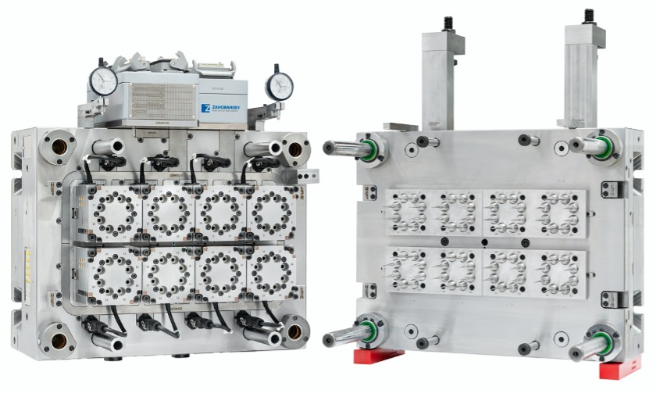 | 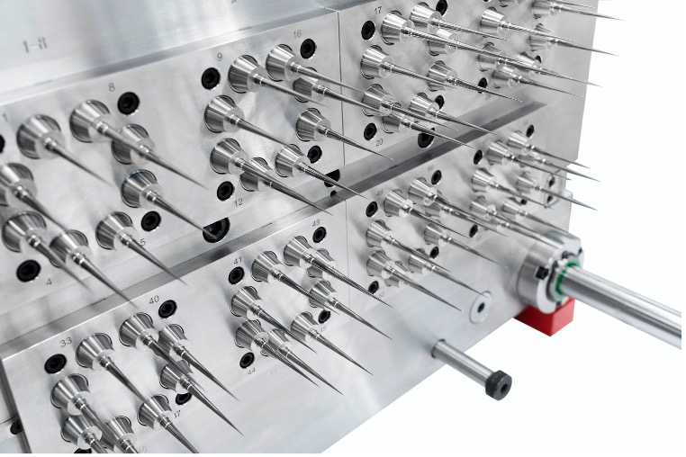
The new pipette tool from ZAHORANSKY powered by KEBO – 64 Cavity | If a core breaks during production, it can be replaced quickly.

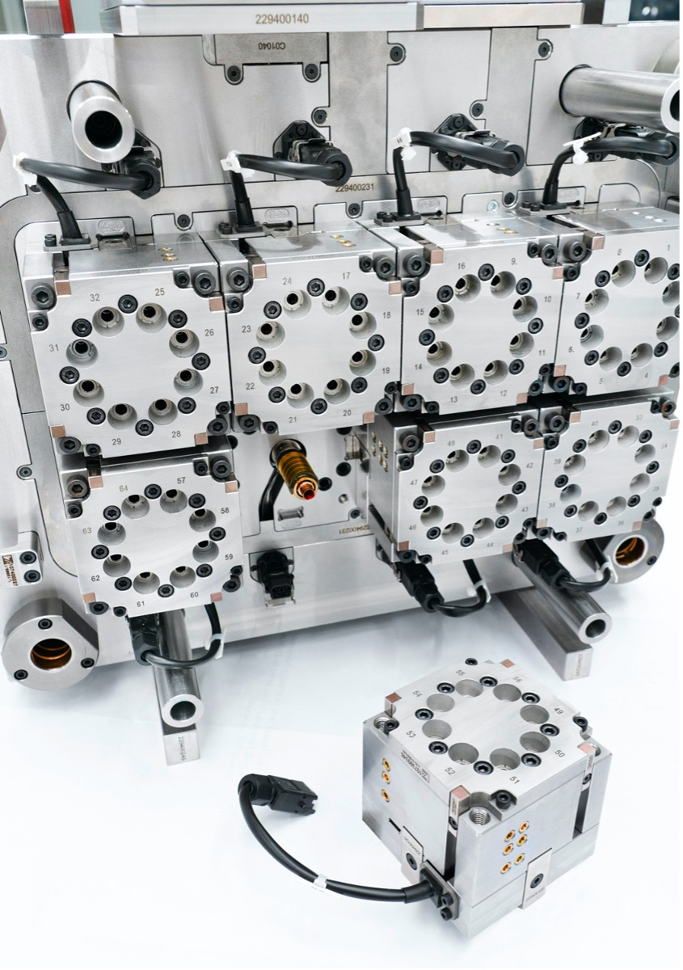
Each heating element can be removed individually in a few simple steps. | The heater can be disconnected via the cable and the block including the heating element can be removed.

Further information:  ZAHORANSKY Automation & Molds GmbH  Michael Schmidt, Managing Director  Bebelstraße 11a, 79108 Freiburg  Tel.: +49 (0) 761 7675 175  Fax: +49 (0) 761) 7675 142  E-Mail: michael.schmidt@zahoransky.com  www.zahoransky.com | Presse- und Öffentlichkeitsarbeit:  Press'n'Relations GmbH  Nataša Forstner, Thomas Seibold  Magirusstr. 33, 89077 Ulm  Tel. +49 (0) 731 96287-17 bzw. 19  Fax +49 (0) 731 96287-97  E-Mail: nfo@press-n-relations.de, ts@press-n-relations.de  www.press-n-relations.de

