A mono-material toothbrush by ZAHORANSKY and Evonik

Freiburg, March 6th, 2023. Every year, billions of used toothbrushes end up in landfills worldwide. A mono-material toothbrush developed by ZAHORANSKY together with Evonik in just five months breaks this cycle. It can be directly reintroduced into the recycling process because instead of using different materials for the handle, headpiece, and bristles, only one is used here. The polyamide 12 (PA 12) material used is based on long-chain polyamides (LCPA), which Evonik markets under the name VESTAMID. Ingo Kumpf, Head of Research & Development ZAHORANSKY AG, elaborates on the special properties of the material: "The PA 12 material is well suited for the production of handles and filaments, as it has comparably positive processing properties to the common fossil-based materials PA6.12 or PBT." PA 12 was easy to process both in the ZAHORANSKY injection mold for handle production and in the tufting machine. As a result, it was possible to meet the tight time window from the initial idea in June to the start of the K trade show in October.

Due to the time pressure, the "fair toothbrush" still had to be conventionally tufted using anchor technology, as machines were only available for this type of anchoring. However, the goal is to produce a version without metal anchors. ZAHORANSKY plans to take further development steps in 2023 to produce a purely bio-based toothbrush. After use, this can be recycled as a mono-material toothbrush.

Johannes-Florian Krampe, Manager Filaments & New Business Development | High Performance Polymers at Evonik, is pleased with the successful project: "Since this toothbrush is made from a single material, it would be completely recyclable. Because that should be our social goal: Recyclable products from which a circular economy can be built." According to Krampe, the PA 12 material "offers the potential for further products made from biobased materials. In these cases, fossil raw materials no longer necessarily have to be used, which conserves global resources and reduces waste mountains in the future."

Image material
You will find the image material in our media portal press-n-relations.amid-pr.com (search term "Mono-material toothbrush"). Of course, we will also be happy to send you the file by e-mail.

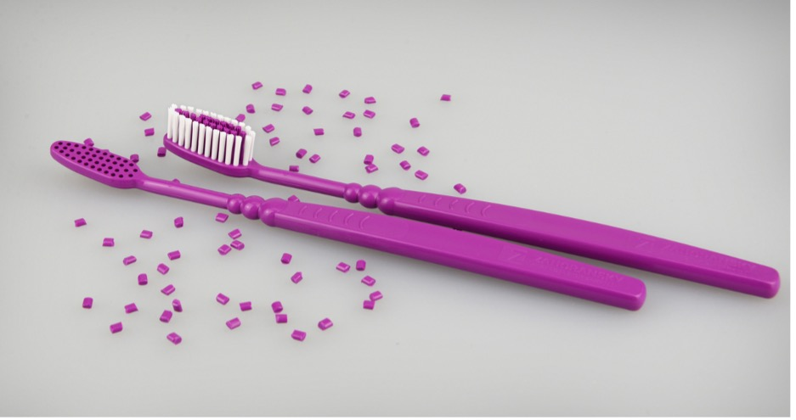
A mono-material toothbrush by ZAHORANSKY and Evonik

Further information:  ZAHORANSKY AG  Robert Dous, Managing Director of ZAHORANSKY Automation & Molds and Chief Sales Officer of ZAHORANSKY GROUP  Anton-Zahoransky-Strasse 1  79674 Todtnau-Geschwend  Tel.: +49 (0) 7671 997-0  Fax: +49 (0) 7671 997-299  Email: robert.dous@zahoransky.com  www.zahoransky.com | Press and public relations:  Press'n'Relations GmbH  Nataša Forstner, Thomas Seibold  Magirusstr. 33, 89077 Ulm  Tel. +49 (0) 731 96287-17 or 19  Fax +49 (0) 731 96287-97  E-Mail: nfo@press-n-relations.de, ts@press-n-relations.de  www.press-n-relations.de

Background information
The name ZAHORANSKY has stood for reliability, precision, and sophisticated technology since 1902. The foundation for this was laid by Anton Zahoransky in his small workshop in Todtnau, where he manufactured the first devices and machines for automated brush production.

Thanks to the experience and expertise gained since then, ZAHORANSKY is now a full-range supplier and technology partner for companies in the brush industry, medical technology, and other sectors. With injection molds, mechanical engineering, automation technology, and packaging systems, ZAHORANSKY can provide comprehensive services for individual requirements. Approximately 900 employees, including 70 trainees, work to achieve this every day at ten locations in Germany, Spain, China, India, Japan, Brazil, and the United States.

ZAHORANSKY’s multi-system solutions cover the entire process chain: from integrating packaging technology and handling, to programming and robotics in the manufacture of fully automated production and assembly systems. ZAHORANSKY's technologies and services are widely used in the following industries: household and industrial brushes, oral care, medical technology, cosmetics, consumer goods, and packaging.

