ZAHORANSKY introduces expanded management team in India
Sathyapriya Balakrishnan is the first woman to join the Top Management Circle

Freiburg (D)/Coimbatore (IND), 26th July 2022. ZAHORANSKY’s subsidiary in Coimbatore/India is being run by a new dual management team since March 1, 2022: Sathyapriya Balakrishnan, who has been at this location since 2017 and was previously Managing Director Reinhard Schnurr's deputy, will be the first woman to join the ZAHORANSKY Group's top management. As Managing Director, she will be responsible for ZAHORANSKY Moulds & Machines Pvt. Ltd. in Coimbatore. Balakrishnan and Schnurr will share joint responsibility for the Indian location, which focuses on mold making and machine assembly. Sathyapriya Balakrishnan says: "I’m very pleased to be part of the ZAHORANSKY Management Circle and am especially excited about the new challenges and opportunities this position will bring."

In addition to her enthusiasm for the job, Sathyapriya Balakrishnan brings all the necessary qualifications to her new role. Along with her degrees such as a Bachelor of Engineering in Electronics and Communications, Master of Business Administration (MBA) in Sales and Marketing, and International Project Management Association (IPMA), she also has a strong knowledge of the industry. She can also draw on specific industry experience from her previous roles as Deputy Managing Director, Project Manager, ZAHORANSKY Lean Administration (ZLA) Coordinator, and Supply Chain Manager.

Image material
Image material can be found in our media portal press-n-relations.amid-pr.com (search term "Personnel ZAHORANSKY India". To do so, please switch the website to "EN" in the upper right corner.). We would also be happy to send you the file by email.

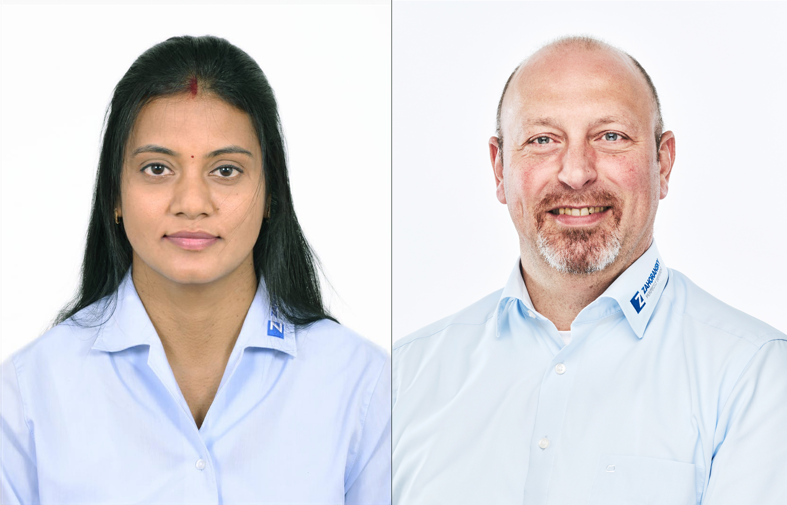
Sathyapriya Balakrishnan, Managing Director ZAHORANSKY, and Reinhard Schnurr, Managing Director ZAHORANSKY

Further information:  ZAHORANSKY AG  Robert Dous, Managing Director ZAHORANSKY Automation & Molds and Chief Sales Officer ZAHORANSKY GROUP  Anton-Zahoransky-Straße 1  79674 Todtnau-Geschwend  Tel.: +49 (0) 7671 997 0  Email: robert.dous@zahoransky.com  www.zahoransky.com | Press and public relations:  Press'n'Relations GmbH  Nataša Forstner, Thomas Seibold  Magirusstr. 33, 89077 Ulm  Tel. +49 (0) 731 96287 17 or 19  Fax +49 (0) 731 96287 97  Email: info@press-n-relations.de, ts@press-n-relations.de  www.press-n-relations.de

Background information
Since 1902, the name ZAHORANSKY has stood for reliability, precision, and advanced technology. The foundation for this was laid by Anton Zahoransky with his small workshop in Todtnau, where he manufactured the first devices and machines for automated brush production.

Today, thanks to the experience and expertise gained since then, ZAHORANSKY has established itself as a full-range supplier and technology partner for companies in the brush industry, medical technology, and other sectors. With injection molds, mechanical engineering, automation, and packaging systems, ZAHORANSKY can offer comprehensive solutions for individual requirements. Approximately 900 employees, 70 of whom are trainees, work every day to achieve this at ten locations in Germany, Spain, China, India, Japan, Brazil, and the USA.

ZAHORANSKY's comprehensive solutions cover the entire process chain: from the integration of packaging technology and handling, to programming and robotics in the manufacture of fully automated production and assembly systems. ZAHORANSKY's technologies and services are in demand in the following industries: household and industrial brushes, oral care, medical technology, cosmetics, consumer goods, and packaging.

